**Phase 1 Practice Project – Assisted Practice**

**8 . Write a program in java to demonstrate the uses of classes, objects, and the object-oriented pillars in java.**

**Class:**

**Source Code:**

**package** Oops;

**public** **class** Student {

**int** id;

String name;

**public** **static** **void** main(String[] args) {

Student s = **new** Student();

System.***out***.println(s.id);

System.***out***.println(s.name);

}

}

**Output:**

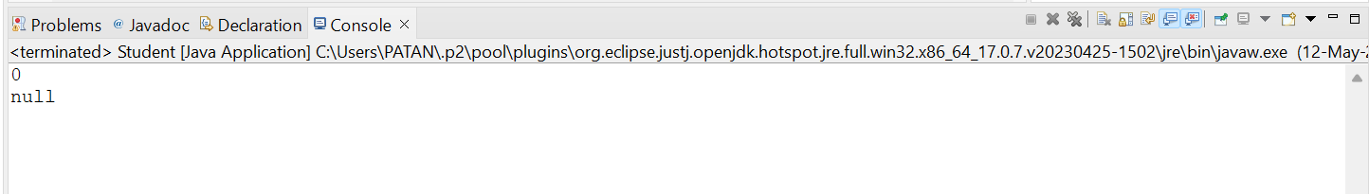

**Object:**

**Source Code:**

package Oops;

import java.io.*;

import java.util.*;

public class Rectangle {

int length,breadth;

void getData(int l, int b) {

length = l;

breadth = b;

}

int rectArea()

{

int area = length * breadth;

return area;

}

public static void main(String[] args) {

Rectangle r = new Rectangle();

r.getData(5, 6);

int a = r.rectArea();

System.out.println(a);

}

}

**Output:**

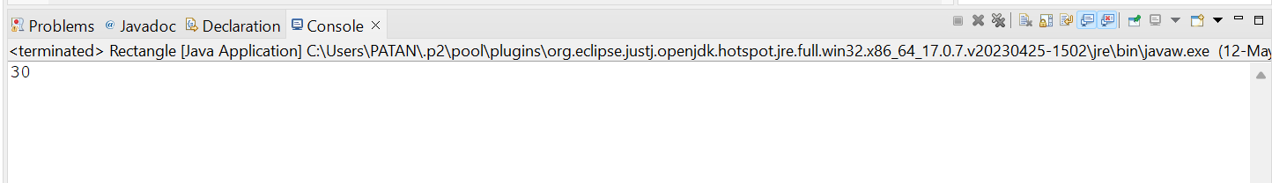

**Encapsulation:**

**Source Code:**

package Oops;

import java.io.*;

import java.lang.*;

public class EncapsulationCls {

private int ssn;

private String empName;

private int empAge;

//Getter and Setter methods

public int getEmpSSN(){

return ssn;

}

public String getEmpName(){

return empName;

}

public int getEmpAge(){

return empAge;

}

public void setEmpAge(int newValue){

empAge = newValue;

}

public void setEmpName(String newValue){

empName = newValue;

}

public void setEmpSSN(int newValue){

ssn = newValue;

}

}

**package** Oops;

**import** java.io.*;

**import** java.lang.*;

**public** **class** EncapsulationTest {

**public** **static** **void** main(String[] args) {

EncapsulationCls obj = **new** EncapsulationCls();

obj.setEmpName("Mittu");

obj.setEmpAge(23);

obj.setEmpSSN(112233);

System.***out***.println("Employee Name: " + obj.getEmpName());

System.***out***.println("Employee SSN: " + obj.getEmpSSN());

System.***out***.println("Employee Age: " + obj.getEmpAge());

}

}

**Output:**

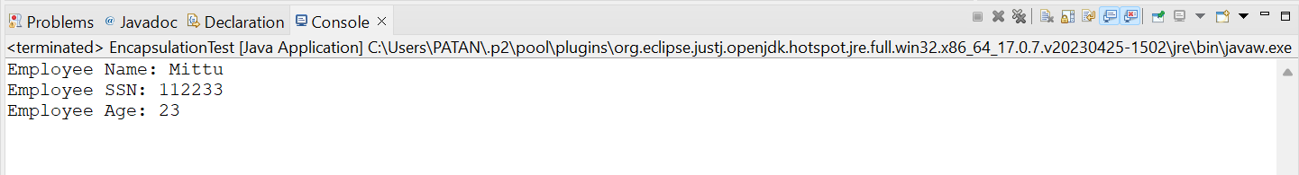

**Abstraction:**

**Source Code:**

**package** Oops;

**abstract** **class** Colors {

**abstract** **void** color();

}

**package** Oops;

**public** **class** White **extends** Colors{

**void** color() {

System.***out***.println("This is White color");

}

}

**package** Oops;

**public** **class** Colorization {

**public** **static** **void** main(String args[]){

White w = **new** White();

w.color();

}

}

**Output:**

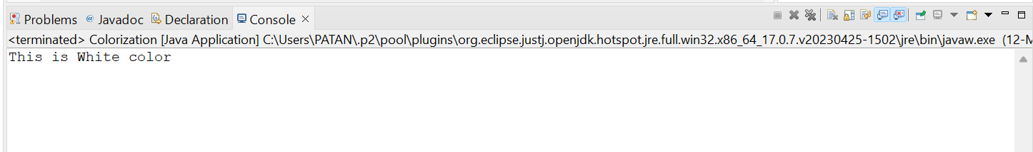

**Polymorphism:**

**Source Code:**

**package** Oops;

**public** **class** Canteen {

String name;

**public** **void** eat() {

System.***out***.println("I'm in Canteen");

}

}

**package** Oops;

**public** **class** Cake **extends** Canteen {

**public** **void** order()

{

System.***out***.println("I ordered Cake : "+name);

}

}

**package** Oops;

**public** **class** ClgCanteen {

**public** **static** **void** main(String[] args) {

// create an object of the subclass

Cake c = **new** Cake();

// access field of superclass

c.name = "Chocolate";

c.order();

c.eat();

}

}

**Output:**

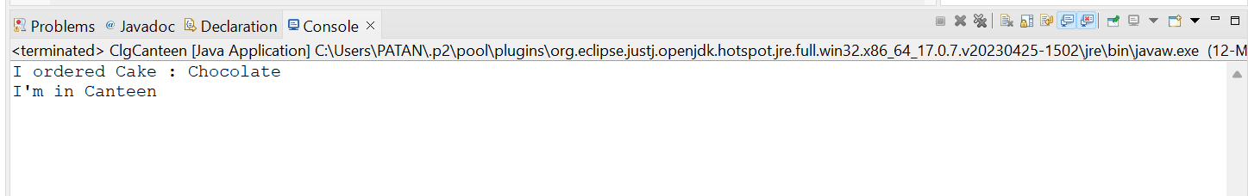

**Inheritance:**

**Source Code:**

**package** Oops;

**public** **class** Cloths {

**public** **void** type() {

System.***out***.println("There are many types of Cloths");

}

}

**package** Oops;

**class** Silk **extends** Cloths{

**public** **void** type() {

System.***out***.println("Silk is one type of Cloth");

}

}

**package** Oops;

**public** **class** Cotton **extends** Cloths {

**public** **void** type() {

System.***out***.println("Cotton is one type of Cloth");

}

}

**package** Oops;

**public** **class** Shoreroom {

**public** **static** **void** main(String[] args) {

Silk s = **new** Silk();

s.type();

Cotton c = **new** Cotton();

c.type();

}

}

**Output:**

